Problem 1:
Write an 8086 program that takes an initial byte value 0A5h. Apply NOT to invert all bits, AND 0F0h to clear the lower nibble, OR 0Fh to set the lower nibble, and XOR 5Ah to toggle specific bits. Display each resulting byte in hexadecimal on the console

Codes:
.model small
.stack 100h
.data
val db 0A5h
l1 db 'NOT: $'
l2 db 'AND: $'
l3 db 'OR: $'
l4 db 'XOR: $'
nl db 13,10,'$'
.code
main proc
mov ax, @data
mov ds, ax
lea dx, l1
mov ah, 09h
int 21h
mov al, val
not al
call print_hex
lea dx, nl
mov ah, 09h
int 21h
lea dx, l2
mov ah, 09h
int 21h
mov al, val
and al, 0F0h
call print_hex
lea dx, nl
mov ah, 09h
int 21h
lea dx, l3
mov ah, 09h
int 21h
mov al, val
or al, 0Fh
call print_hex
lea dx, nl
mov ah, 09h
int 21h
lea dx, l4
mov ah, 09h
int 21h
mov al, val
xor al, 5Ah
call print_hex
lea dx, nl
mov ah, 09h
int 21h
mov ah, 4Ch
int 21h
main endp
print_hex proc
push ax
push bx
push cx
push dx
mov cl, 4
mov ch, 2
hex_loop:
rol al, cl
mov bl, al
and bl, 0Fh
cmp bl, 9
jbe digit
add bl, 7
digit:
add bl, 30h
mov dl, bl
mov ah, 02h
int 21h
dec ch
jnz hex_loop
pop dx
pop cx
pop bx
pop ax
ret
print_hex endp
end main

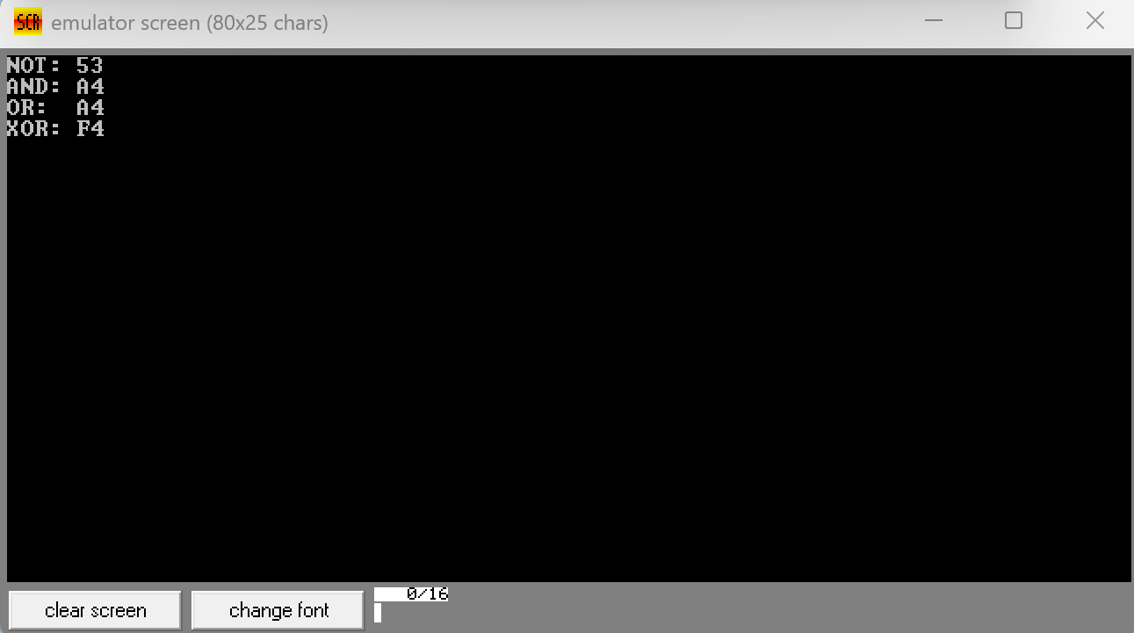
Output:
Problem 2:
Write a program that loads the byte 14h into a register. Use SHL with a count of 3 to multiply the value by 8, and SHR with a count of 2 to divide the original value by 4. Print both results in hexadecimal.

Codes:
.model small
.stack 100h
.data
val db 14h
l1 db 'SHL*8: $'
l2 db 'SHR/4: $'
nl db 13,10,'$'
.code
main proc
mov ax, @data
mov ds, ax
lea dx, l1
mov ah, 09h
int 21h
mov al, val
mov cl, 3
shl al, cl
call print_hex
lea dx, nl
mov ah, 09h
int 21h
lea dx, l2
mov ah, 09h
int 21h
mov al, val
mov cl, 2
shr al, cl
call print_hex
lea dx, nl
mov ah, 09h
int 21h
mov ah, 4Ch
int 21h
main endp
print_hex proc
push ax
push bx
push cx
push dx
mov cl, 4
mov ch, 2
hex_loop:
rol al, cl
mov bl, al
and bl, 0Fh
cmp bl, 9
jbe digit
add bl, 7
digit:
add bl, 30h
mov dl, bl
mov ah, 02h
int 21h
dec ch
jnz hex_loop
pop dx
pop cx
pop bx
pop ax
ret
print_hex endp
end main

Output:
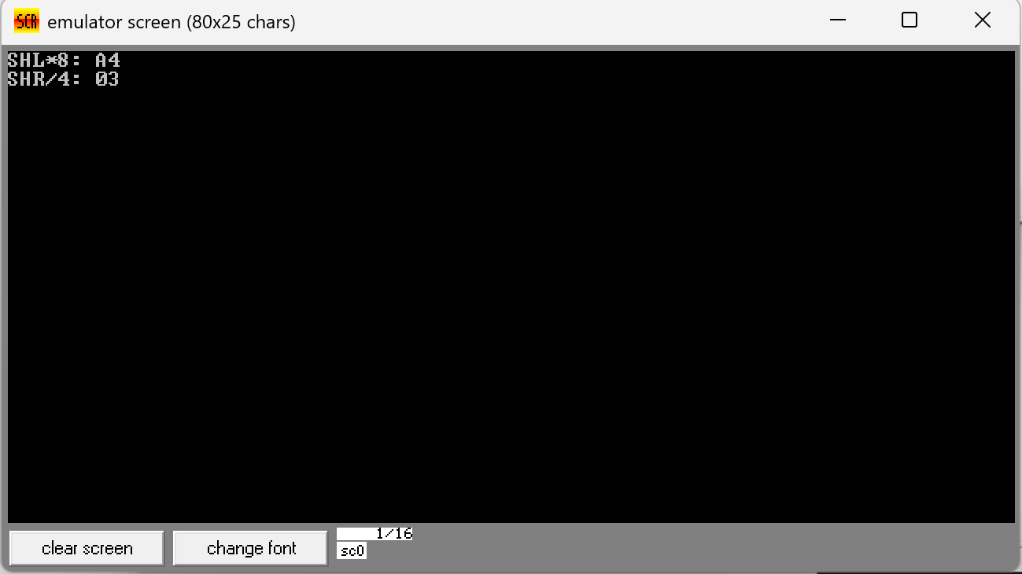

Problem 3:
Write a program that loads the signed byte 0ECh (-20). Use SAL with a count of 1 to multiply by 2 while preserving sign, and SAR with a count of 1 to divide by 2 while preserving sign. Print both results in hexadecimal.

Codes:
.model small
.stack 100h
.data
val db 0ECh
l1 db 'SAL*2: $'
l2 db 'SAR/2: $'
nl db 13,10,'$'
.code
main proc
mov ax, @data
mov ds, ax
lea dx, l1
mov ah, 09h
int 21h
mov al, val
mov cl, 1
sal al, cl
call print_hex
lea dx, nl
mov ah, 09h
int 21h
lea dx, l2
mov ah, 09h
int 21h
mov al, val
mov cl, 1
sar al, cl
call print_hex
lea dx, nl
mov ah, 09h
int 21h
mov ah, 4Ch
int 21h
main endp
print_hex proc
push ax
push bx
push cx
push dx
mov cl, 4
mov ch, 2
hex_loop:
rol al, cl
mov bl, al
and bl, 0Fh
cmp bl, 9
jbe digit
add bl, 7
digit:
add bl, 30h
mov dl, bl
mov ah, 02h
int 21h
dec ch
jnz hex_loop
pop dx
pop cx
pop bx
pop ax
ret
print_hex endp
end main

Output:
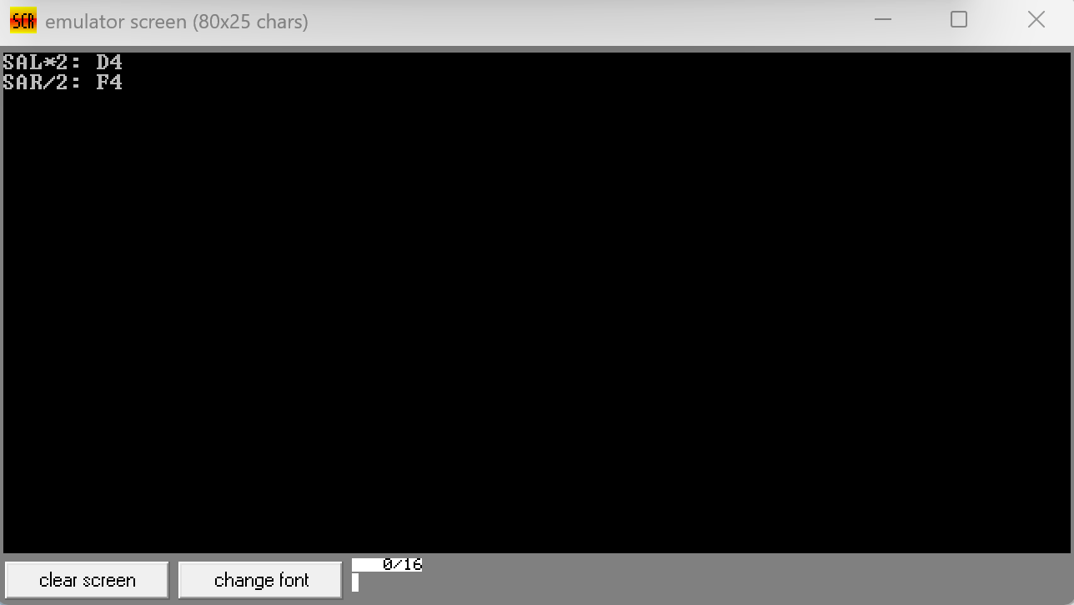

Problem 4:
Write a program that loads the byte 0A5h. Perform a left rotate by 3 bits, a right rotate by 3 bits, and swap the high/low nibbles by rotating left by 4 bits. Print each result in hexadecimal.

Codes:
.model small
.stack 100h
.data
val db 0A5h
l1 db 'ROL 3: $'
l2 db 'ROR 3: $'
l3 db 'SWAP:$'
nl db 13,10,'$'
.code
main proc
mov ax, @data
mov ds, ax
lea dx, l1
mov ah, 09h
int 21h
mov al, val
mov cl, 3
rol al, cl
call print_hex
lea dx, nl
mov ah, 09h
int 21h
lea dx, l2
mov ah, 09h
int 21h
mov al, val
mov cl, 3
ror al, cl
call print_hex
lea dx, nl
mov ah, 09h
int 21h
lea dx, l3
mov ah, 09h
int 21h
mov al, val
mov cl, 4
rol al, cl
call print_hex
lea dx, nl
mov ah, 09h
int 21h
mov ah, 4Ch
int 21h
main endp
print_hex proc
push ax
push bx
push cx
push dx
mov cl, 4
mov ch, 2
hex_loop:
rol al, cl
mov bl, al
and bl, 0Fh
cmp bl, 9
jbe digit
add bl, 7
digit:
add bl, 30h
mov dl, bl
mov ah, 02h
int 21h
dec ch
jnz hex_loop
pop dx
pop cx
pop bx
pop ax
ret
print_hex endp
end main

Output:
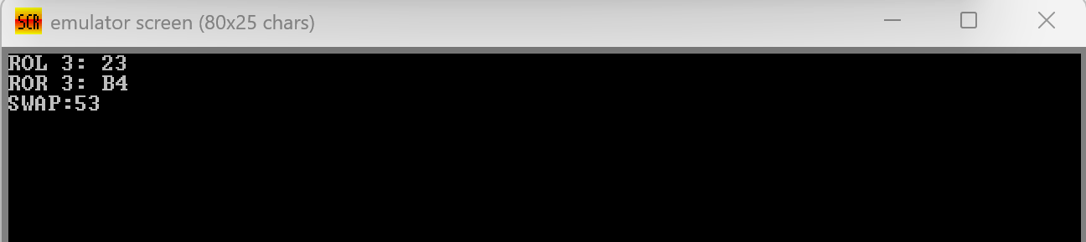
Problem 5:
Write a program that counts the number of set bits in 0B3h using RCL in a loop, demonstrates carry propagation by setting CF with STC and rotating 0F0h through carry, and uses TEST to check if bits 7-4 are set in 0AAh. Print all three results in hexadecimal.

Codes:
.model small
.stack 100h
.data
val db 0B3h
l1 db 'BIT CNT:$'
l2 db 'CARRY :$'
l3 db 'TEST :$'
nl db 13,10,'$'
.code
main proc
mov ax, @data
mov ds, ax
lea dx, l1
mov ah, 09h
int 21h
mov al, val
mov cl, 8
xor ah, ah
clc
count_loop:
rcl al, 1
jnc skip
inc ah
skip:
dec cl
jnz count_loop
mov al, ah
call print_hex
lea dx, nl
mov ah, 09h
int 21h
lea dx, l2
mov ah, 09h
int 21h
mov al, 0F0h
stc
rcl al, 1
call print_hex
lea dx, nl
mov ah, 09h
int 21h
lea dx, l3
mov ah, 09h
int 21h
mov al, 0AAh
test al, 0F0h
jz zero
mov bl, 0FFh
jmp done
zero:
mov bl, 00h
done:
mov al, bl
call print_hex
lea dx, nl
mov ah, 09h
int 21h
mov ah, 4Ch
int 21h
main endp
print_hex proc
push ax
push bx
push cx
push dx
mov cl, 4
mov ch, 2
hex_loop:
rol al, cl
mov bl, al
and bl, 0Fh
cmp bl, 9
jbe digit
add bl, 7
digit:
add bl, 30h
mov dl, bl
mov ah, 02h
int 21h
dec ch
jnz hex_loop
pop dx
pop cx
pop bx
pop ax
ret
print_hex endp
end main

Output:
